Guide to Run Certification Project

External Dependency:

Following postgres Database need to be available for different service.

1. Database for Order and Cart:

Database Name: orders

2. Database for Products:

Database Name: products

3. Database for User:

Database Name: users

Please update DB login credentials in respective properties files of Order,User,Product services

Run All Web service:

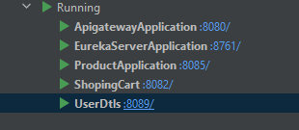

Creating Category:

<http://localhost:8080/productms/api/create-category>

Post: discription= Enter the Description of category.

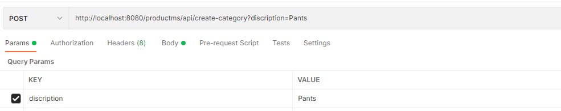

List Category:

GET

<http://localhost:8080/productms/api/category> (List All Available Category with ID)

Create Products:

<http://localhost:8080/productms/api/create-product>

Post: {

   "category": {

     "idcategory": ***id of category*** },

   "description": ***Discription of Irem ***,

   "price": 1999,

   "stock": 10

}

List Products:

GET

<http://localhost:8080/productms/api/products> (List All Products)

**For Order MS authentication is required:**

Create User:

<http://localhost:8080/customerms/users/register>

Post:

{

"email": "string",

"full_address": "string",

"name": "string",

"password": "string",

"phone": "string",

"username": "string",

"zip_code": "string"

}

On Successful Creation Get a auth token from

<http://localhost:8080/customerms/users/authenticate>

POST : {

   "password": "string",

 "username": "string"

}

Following Token Will be used in Order MS:

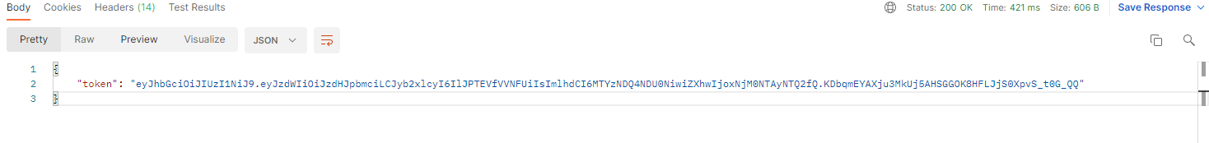

Create Cart :

<http://localhost:8080/ordes/cart/createCarts>

Header:

Authorization Bearer **TOKEN**

Post :

{

   "products": [

   {

     "idProduct": 1,

     "description": "string",

     "price": 100,

     "stock": 1

   }

   ],

   "subtotal": 0

}

GET order:

GET:

[http://localhost:8080/ordes/cart/getCart/{idCart}](http://localhost:8080/ordes/cart/getCart/%7bidCart%7d)

Update Cart:

Put:

[http://localhost:8080/ordes/cart/getCart/{idCart}](http://localhost:8080/ordes/cart/getCart/%7bidCart%7d)

**[**

**{**

**"description": "string",**

**"idProduct": 0,**

**"price": 0,**

**"stock": 0**

**}**

**]**

Create Order:

<http://localhost:8080/ordersms/order/createOrder>

Header:

Authorization Bearer **TOKEN**

Post:

{

    "cartId":5

}

Get Order:

GET:

http://localhost:8080/ordersms/order/getOrder/{orderId}